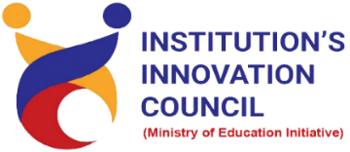
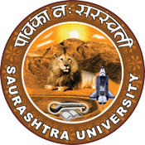

Celebration of National Start-up Day

16 January 2023
At
Seminar hall, NFDD Building
Saurashtra University Campus, Rajkot
Contents
Saurashtra University – IIC 2
Event Schedule 2
Event Registration Link 2
Brief about Event 3
Key Points 3
Outcome 4
About the Speaker/Chief Guest 5
Connect Us: 7

Saurashtra University – IIC
The university is dedicated to instruction, research, and extending knowledge to the public (public service). Ministry of Education (MoE), Govt. of India has established ‘MoE’s Innovation Cell (MIC)’ to systematically foster the culture of Innovation among all Higher Education Institutions (HEIs). The primary mandate of MIC is to encourage, inspire and nurture young students by supporting them to work with new ideas and transform them into prototypes while they are informative years. Saurashtra University is one the Organization that have constituted the IIC to foster the vision of MoE and be a part for the promotion and development of innovation ecosystem.

Event Schedule

Event Registration Link

bit.ly/SUSEC-NSD23

Brief about Event

We had celebrated National Start-up Day - 16 January 2023 to spread awareness about conserving Start-up by organizing a session on "How to Start-up & Intellectual Property Rights". Students and Faculty of Saurashtra University participated and celebrated National Start-up Day enthusiastically.
This seminar’s objective is to gain insights about start-ups, entrepreneurship, government funding scheme etc. This involves five stages of start-ups like idea, launch, validation & decision, growth and transition. In this seminar discuss about equation of start-up, essential element of success and also understand start-ups mistakes. India also needs more entrepreneur for start-up growth.
Also, in this seminar discussed about Intellectual Property in that the first stage involves filing an application, which is followed by its publication by the Patent Office was made understood by the speaker. Also, many examples of patents, Trademarks, Designs and copyrights were given by Speaker.
Awareness regarding various types of IP including Patent, Trademark, Design, Copyright, Integrated Circuit Design and Plant Varieties registration was carried out. It was related to Intellectual property and awareness creation, a basic knowledge of intellectual property, how it works, how it can be registered, with various examples.
Details, eligibility, how to apply, who can apply and importance of the IP was introduced.
After completion of the seminar, participants are able to acquire more knowledge on How to Start-up?

Key Points

During the session, below mentioned points were discussed:
- Factors effect to start-up
- Equation of start-up
- Five stages of start-ups
- Finding the problems & identify problems
- Start-ups mistakes
- IPR Support
- Significance of Intellectual property
- Importance of IP
- Geographic Indications (GI)
- SICLD (Semiconductor Integrated Circuits Layout-Design)
- How to apply for Patent, Trademark, Design Registration and Copyright registration
- FAQs related to How to Start-up & Intellectual Property Rights

Outcome

As per the event, various types of Start-ups, Importance of Start-ups and Various Start-up Grants was made understood by the speaker. Also, various types of IP and who can apply were understood by the speaker with various examples.
It was related to Intellectual property and awareness creation, a basic knowledge of intellectual property, how it works, how it can be registered, with various examples of Trademark, Copyright, patents etc. It was very good informative session. Students learn a lot about various type of Intellectual property for patent, design, copyrights. How to file it and various process etc.
Also, as it was related to Start-up design and awareness creation, a basic knowledge of how-to Start-up, how it works, how to use Central and state government policies & funding opportunities, with various examples of Start-up etc.

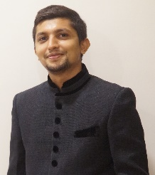
About the Speaker/Chief Guest
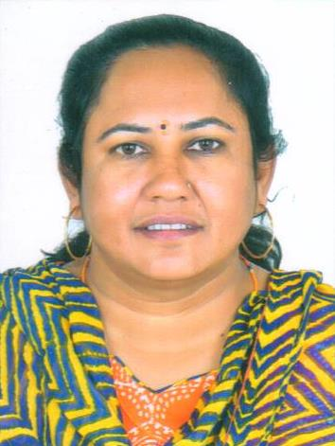

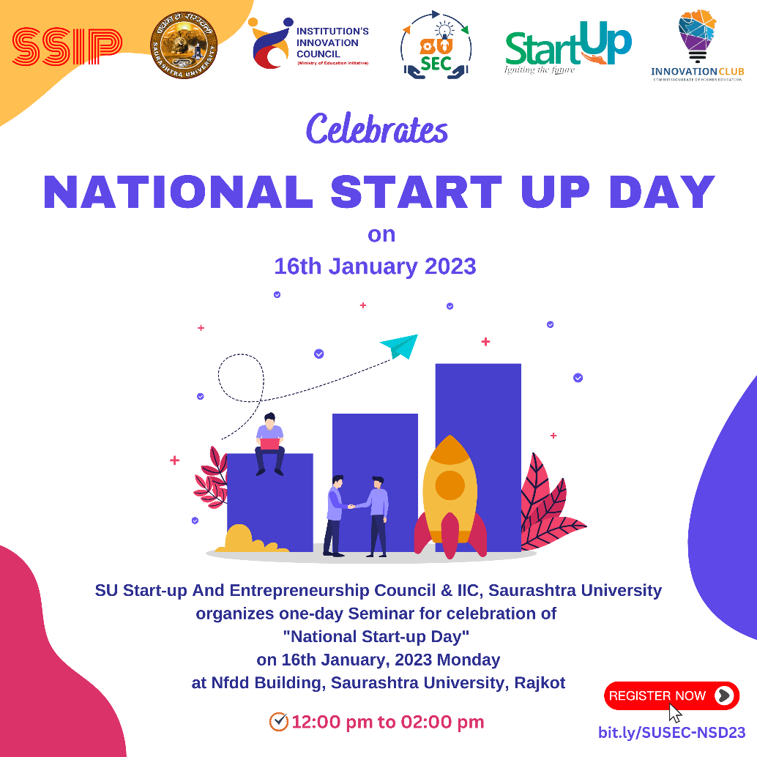

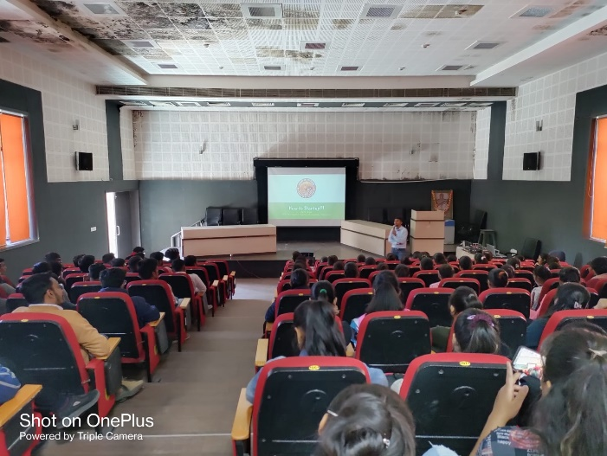
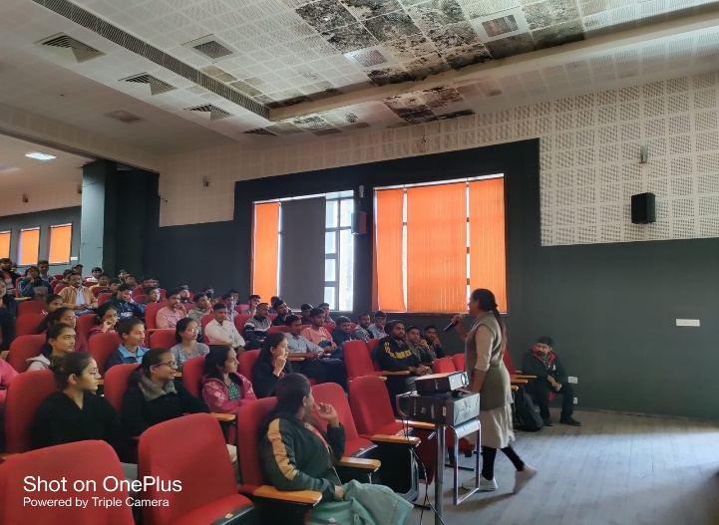
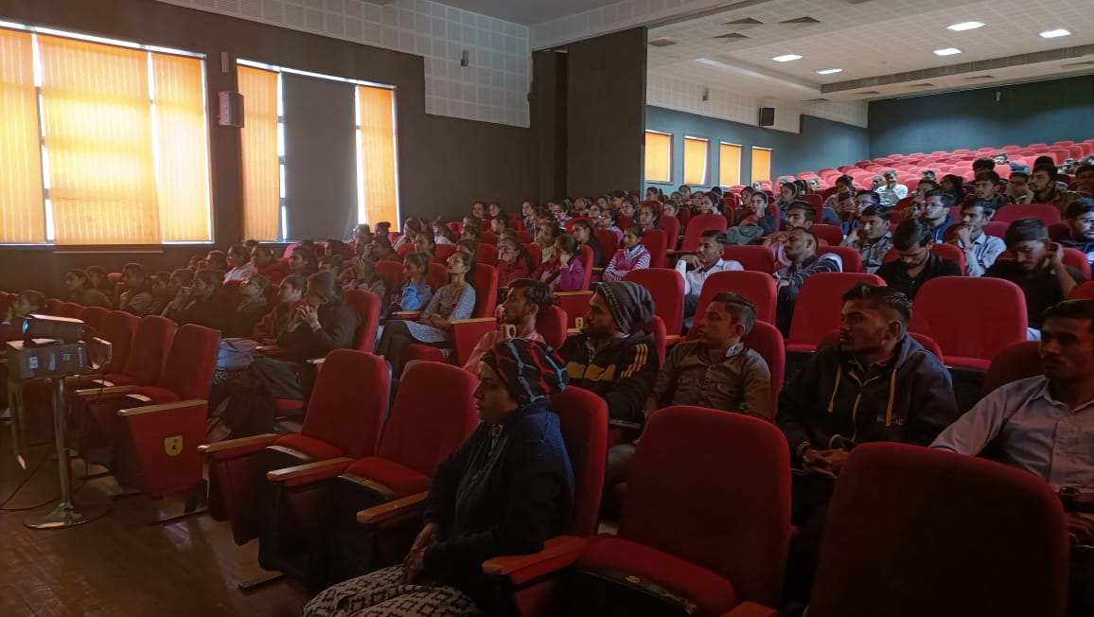
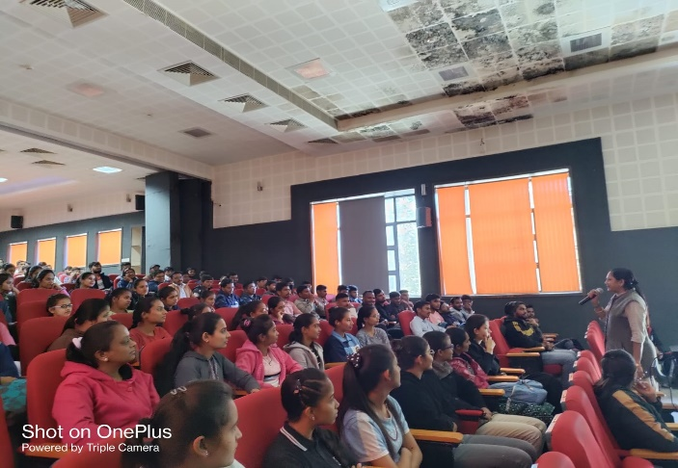

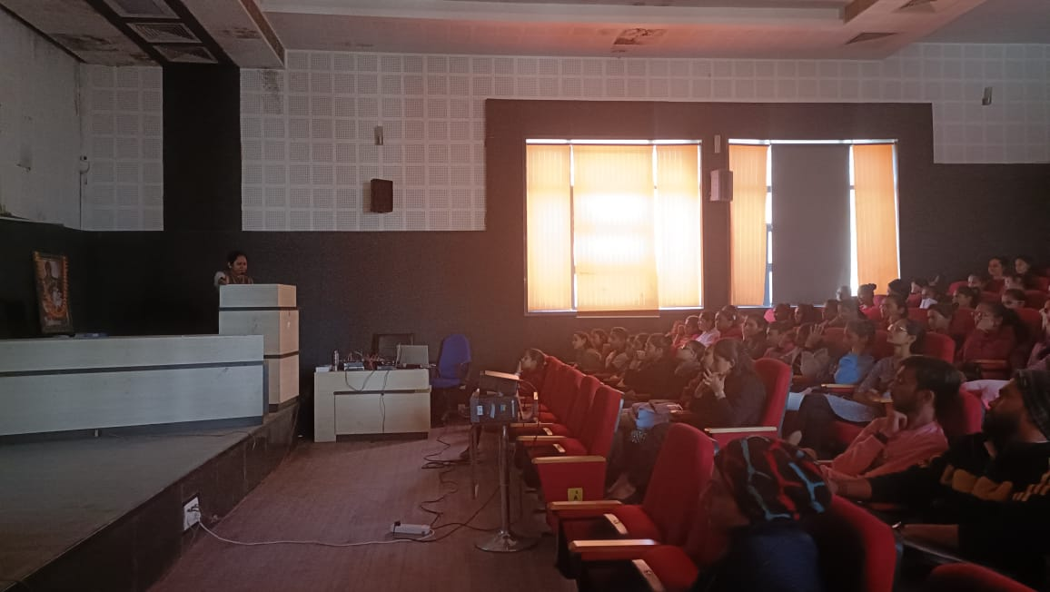
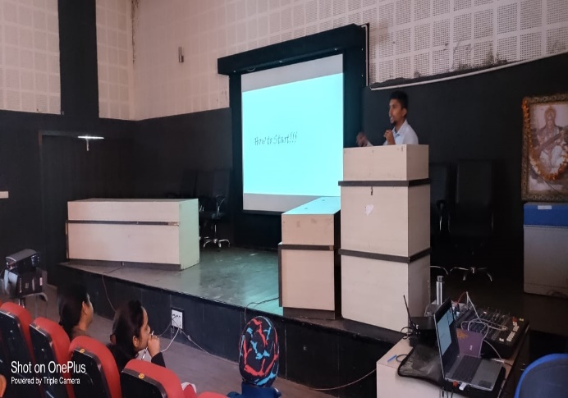

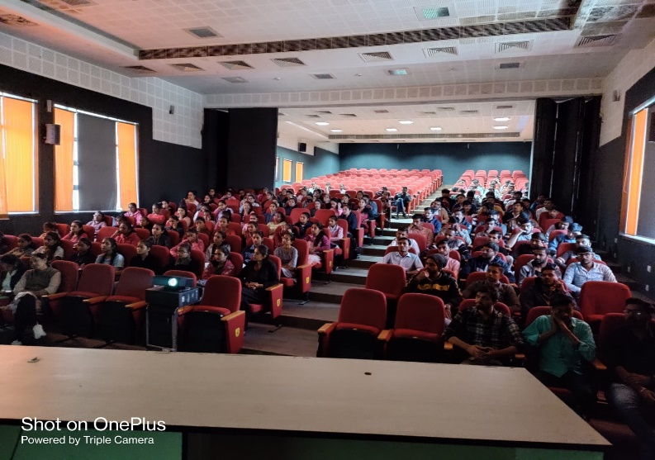
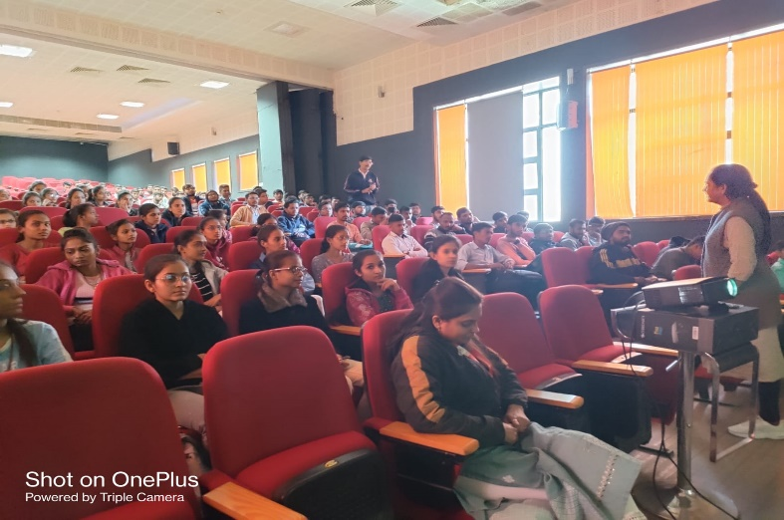

Connect Us:

https://www.linkedin.com/company/susec iic@sauuni.ac.in
https://www.facebook.com/iicsauuni bit.ly/SU-SSIP Location
https://www.instagram.com/susecrajkot https://bit.ly/SUSEC-youtube

